**Activity 24**

**NAME : M.Varshini COURSE : Mobile Computing Reg No : 192421293 COURSE CODE: ITA0302**

24 . Use Figma to design a flowchart demonstrating the lifecycle of an Android Intent, including explicit and implicit intents.

**Aim :**

Design a flowchart demonstrating the lifecycle of an Android Intent, including explicit and implicit intents.

**Procedure: -** 1. Open Figma

1. Create a new file
2. Click on the resources icon and click on the plugins
3. Search for the Flow Chart
4. Drag and drop the shapes on the screen
5. Now, enter the content on the shapes and connect them through Arrows.
6. Grouping and alignment
7. Review and edit
8. Save and share

**Design :**

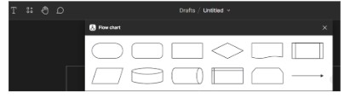

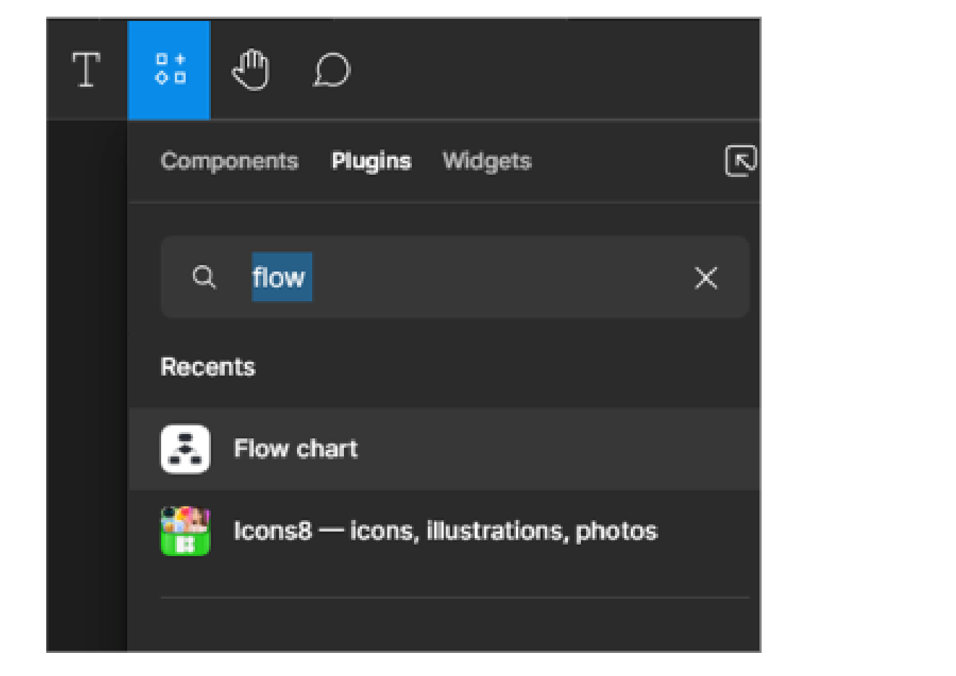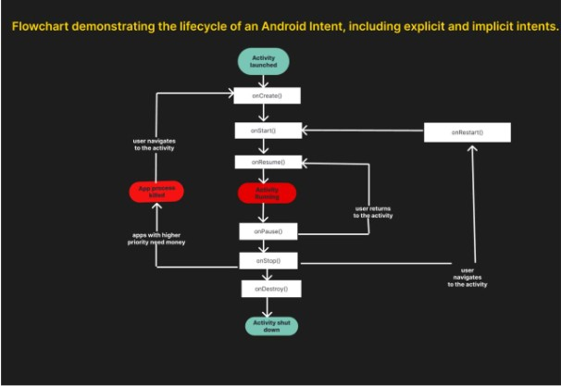

Result :

Hence the flowchart in Figma explaining the lifecycle of an Android Intent, including explicit and implicit intents.